Manan Madan

2018UIC3087

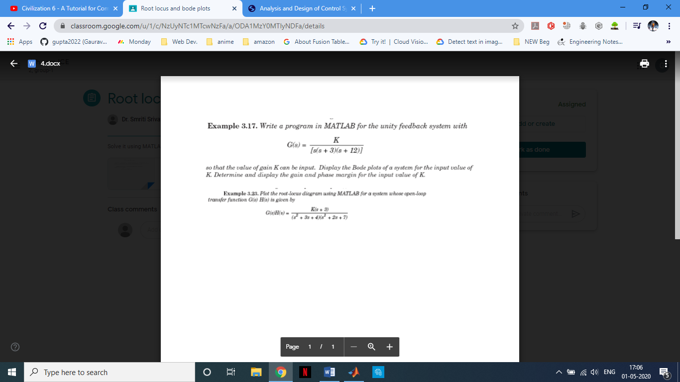

Solution

G =

1

-------------------

s^3 + 15 s^2 + 36 s

Bode Plot :

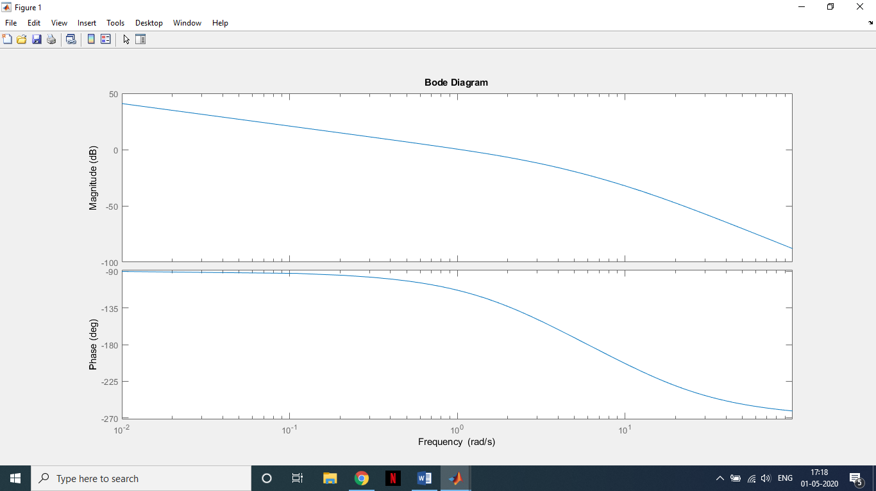

Gain K = 40

Frequency(180 degree) = 6.01

Magnitude = 0.0738277

Magnitude(dB) = – 22.6356

Phase = – 180.076  **Gain margin(dB) = 22.6356**

Gain K = 40

Frequency(0 dB) = 1.11

Magnitude = 0.93481

Magnitude(dB) = – 0.585534

Phase = – 115.589, **Phase margin(dB) = 64.4107**

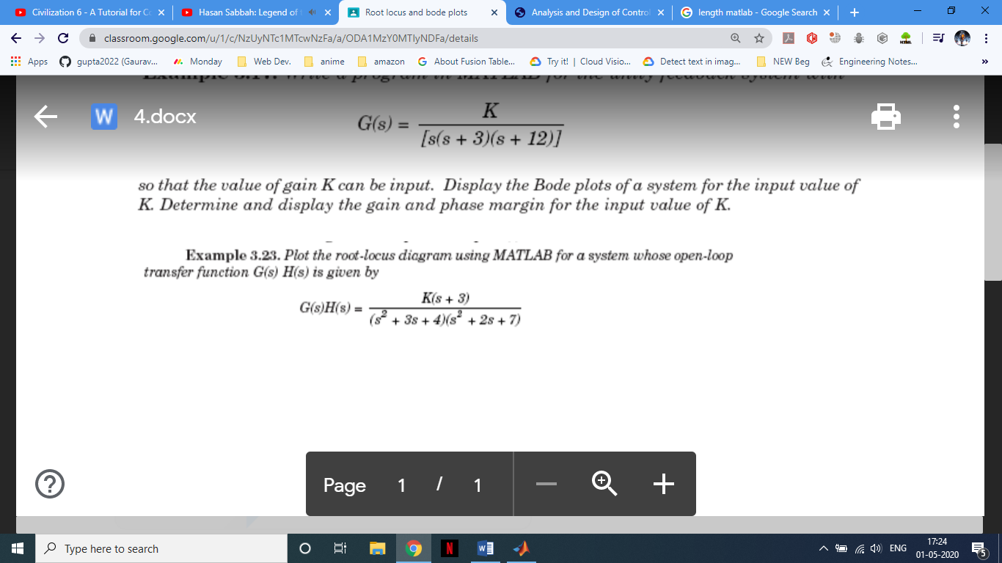

$G\left(s\right)H\left(s\right)=\frac{K\left(s+3\right)}{\left(s^{2}+3s+4\right)\left(s^{2}+2s+7\right)}$

$G\left(s\right)H\left(s\right)=\frac{K\left(s+3\right)}{\left(s^{4}+{5s}^{3}+{17s}^{2}+29s+28\right)}$

